TITLE OF THE PROJECT

INTRODUCTION

All Products was established in 1994 and since that time has grown into one of the countries largest importers and distributors of All Products like laptop, computer, clothes, wears shoes and peripherals.
The growth of the company over the past eighteen months has been extremely exciting, as new product ranges have been launched and new partnerships developed with both suppliers and dealers.
Consistent with this growth, has been our expansion into sourcing new products from international suppliers, ensuring that we can continue to supply the highest quality products at the best prices in the industry.
In May of 2007, the focus of All Products widened still further with the launch a new business to business web site and the regrinding of the company.
Our product range is now packaged in our new, high impact and identifiable branding, which together with an increased quality of product will become the hallmark of All Products.
The team here is focused on providing, not only the best and most innovative products, but also on delivering the best service to our clients.
Our product range is expanding fast and we will keep you up to date with all new launches.

OBJECTIVES

PowerBuyer with a variety of All Products these includes laptop, computer, and clothes, wears shoes and peripherals.
For us, customer service is not just a credo, but a success strategy, since we have found our satisfied customers bringing us new customers, helping us grow without conventional promotional and advertising activity.
It is this strategy and credo that we offer to you.
Besides customer service, what drives us is our conviction, that the internet can transform the way we shop - save us time and money, and most importantly, help us get exactly what we want. Only you, our customer know what you want. Our business is to help you share that with us, so that we can increasingly find a closer match to it. Eventually, we would like to proactively notify you of what you may be interested in. In any event, our stores should be increasingly able to reflect the ability to fulfill your needs, uniquely and completely. We could call that our mission.
Our vision is an internet All shopping experience that is highly intuitive and interactive and enables all customers to customize the merchandize or service that they want.
It is this vision that we bring to Ebigbazar.com. As the name implies, we would like to deliver unprecedented value products to you, be it in terms of price, or delivery or post-sales service or tailored products to suit your specific needs. We value your business and deem it a great privilege to serve you. We promise you the best, and more to come along the same lines.

PROJECT CATEGORY

- ASP.NET
ASP.NET. a web application development technology by Microsoft. Programmers can use it to build dynamic web sites, web applications and XML web services. It is part of Microsoft's .NET platform and is the successor to Microsoft's Active Server Pages (ASP) technology.ASP.NET is built on the Common Language Runtime, meaning programmers can write ASP.NET code using any Microsoft .NET language.
Differences compared to ASP classic are
- Compiled code: faster applications, more design-time errors trapped.
- Improved run-time error handling, exception handling
- Rich user interfaces, controls and events.
- Extensive set of controls, class libraries, user defined controls, templates, such as menus. Easier layout..
- Multi-language capabilities of the .NET CLR, allowing web pages to be coded in VB.NET, C#, J#, etc.
- All controls generate valid HTML 4.0, XHTML 1.0 (the default) or XHTML 1.1 output, support for Cascading Style Sheets is more extensive.

Features of ASP.NET
In addition to hiding script commands, ASP. NET has the following advanced features that help to develop robust web applications:
1] Compiled Code: Here code is compiled not interpreted, thus making it faster than the Server side scripts that are interpreted [E.g.- ASP]
2] Enriched tool support: Designed in VS.NET IDE. What you see is what you get editor, drag and drop server controls, automatic deployment.
3] Power and Flexibility: Of the .NET platform since it is based on CLR. Therefore ASP.NET applications ensure you a .NET framework class library, messaging, and data access solutions are seamlessly accessible over the web. It is language independent. Hence, you can use any language to develop your application.
4] Simplicity: Use interfaces separate the application logic from presentation content. In addition, CLR simplifies it further by using managed code services, viz automatic reference counting and garbage collection. Therefore simplifies form submission, client authentication, configuration and deployment.
5] Manageability: Enables you to manage web apps. By storing the configuration information in an XML file. You can open the xml file in the visual studio .NET IDE.
6] Scalability: Improves performance in the multiprocessor environment.
7] Security: Options for security and restricting user access to a web application , present within the configuration file.

- C#.NET
Features:
1] Most suitable building robust, n-tier client server applications.
2] C# with ADO.N ET gives quick access to data stores like SQL server and oracle.
3] It offers XML web services and server side controls.
4]Makes it easy writing windows forms user interfaces
5] Component conflicts become infrequent.
6] Deployment is easier.

- ADO.NET :
ADO.NET is a large set of .NET classes that enable us to retrieve and manipulate data, and update datasources, in very many different ways. As an integral part of the .NET framework, it shares many of its features: features such as multi-language support, garbage collection, just-in-time compilation, object-oriented design,and dynamic caching, and is far more than an upgrade of previous versions of ADO.ADO.NET is set to become a core component of any data-driven .NET application or Web Service, and understanding its power will be essential to anyone wishing to utilize .NET data support to maximum effect.

- HTML
HTML , short for HyperText Markup Language, is the predominant markup language for the creation of web pages
Provides stucture by denoting certain text as headings, paragraphs, lists, and so on — and to supplement that text with interactive forms, embedded images, and other objects.and even embedded code which affects the behaviour of the web browser.
HTML is also often used to refer to content of the MIME type text/html /XHTML .

DHTML
Dynamic HTML (DHTML) is a set of innovative features in Microsoft Internet Explorer 4.0.
With DHTML, you can easily add effects to your documents that previously were difficult to achieve. For example, you can:
- Hide text and images in your document and keep this content hidden until a given time elapses or the user interacts with the page
- Animate text and images in your document, independently moving each element from any starting point to any ending point, following a path that you choose or that you allow the user choose.

JAVA SCRIPT
Java script is the Netscape-developed object scripting language used web pages and server applications.
JavaScript is a dynamic scripting language supporting prototype based object construction.
Function as both a procedural and an object oriented language.

SQL SERVER 2008
Features
1. One of SQL's greatest benefits is it is truly a cross-platform language and a cross-product language.
2. It is the common thread that runs throughout client/server application development is the use client/server computing of SQL and relational databases.
3. SQL SERVER 2008 is recommended where database is not so huge.
4. SQL SERVER 2008 provides good security.

Operating System
In the proposed system Windows 7.
system. Windows File Protection runs in the background and prevents other programs from changing the files needed by the operating system.
It can defragment disk volumes formatted as FAT, FAT32, and NTFS, increasing server reliability and performance.
SYSTEM ANALYSIS

Problem Identification

Problem identification is very first step of system analysis. The analyst meets with the customer and the end user. Here in our case both customers are the companies and user of their products. In this step, we are interested to understand the product’s objective and defined the goals required to meet the objective. After identifying overall goals, we moved towards evaluation of supplementary information during preliminary investigation. We also focused on “Does the technology exit to build the system?” and “What bounds have been placed on costs and schedule?”
To perform it we scanned followings:
- The performance of the system,
- The information being supplied and its form,
- The economy of processing,
- The control of the information processing,
- The efficiency of the existing system, and
- The security of the data & software.

Preliminary Investigation
Once the request for the information system development is received, the first system activity “Preliminary Investigation” begins. This activity is independent of the software-engineering paradigm. That means whether a system will be developed by means of the system development life cycle (SDLC), a prototyping strategy, or the structured analysis method, or a combination of these methods, preliminary investigation must be performed first.
This activity has three parts:
- Request Clarification,
- Study, and
- Approval.

It may be possible that the request that has been received is not clearly defined and it is difficult to figure out what for the request is. So, in that case, the person who has made the request is contacted and asked to explain the request. If the request is appropriate enough then in that case feasibility study is carried out for that request i.e., before the feasibility study, the request must be determined and defined precisely. After request clarification the feasibility study is performed. If the request for the information system is feasible and the request is approved, then starts the real analysis phase called “Requirement study”. The data that are collected from the organization as the part of preliminary investigation is follows three mechanisms also called “Fact Finding Techniques”:
- Reviewing existing Documents material and existing systems (web sites)
- Conducting Interviews and
- On-Site Observation

To conduct preliminary investigation, we came to know that CRC is having their websites with the organization information purposes. The very first impression validates the request for the automation (i.e. Information System development). We used all the three fact-finding techniques for data collection. We collected various papers & documents related to the activities, we analyzed every aspect of the online customer care system, and conducted marketing surveys to know the interest among the people associated and attached with different organization .It was surprising to know that most of them were very interested in computers and has the better understanding of Computer & Information Systems. Both were very helpful in passing the exact information we were looking for. Reviewing the traditional one and having own experience in the field helped us immensely in the knowing the data items being processed by the system. It also helped in understanding the complexities of the working process of the web site.
The above said fact finding techniques not only helped in the understanding of the system but also proposed some solutions to the new information systems.

Information Content:
Information content represents the individual data and control objects that constitute some larger collection of information transformed by the software. In our case the object, which is composite of a number of important pieces of data as project, package and item with its category. So the contents are defined by the necessary attributes required to create it. During the analysis of the information domain the inter relationship between objects is also defined.
Information Flow:
Information flow represents the manner in which data and control changes as each move through a system. Input objects are transformed into intermediate information, which is further transformed to output. Here, additional information is also supplied and transformations are some engineering functions/formulae.
Information Structure:
Information structure represents the internal organization of various data and control items. Some queries are answered like “How does information in one information structure relate to information in another structure?”, “Are all information contained within a single structure or are distinct structure to be used?” etc.

System under Study:
In order to understand the need of the proposed system first we will have to understand the demand and supply of such system accordingly in the real world, and in nowadays context.
With more then 1 billion population of the country like ours, where everything is changing fast and figures complete change in the mod of human interaction changing the direct dependability between man & man and man & machine through the fast growing electronics mode of communication opening a new door for internet technology to act as a interactive media for a professional interaction, this system deals directly with customer interaction with the respective companies for the products and service regarding to that
products. The interaction response time can be decreased through a viable Internet based response, request and query management system.

With the increasing of web broadband network using optical fiber cable the system being developed is feasible and cannot act as a trusted mode of communication between companies and their customers.

Engulfing the vast possibility of growth in the customer care industry at home or at a communication hub like cyber cafes. One cannot deny the possibility of good customer care industry through the net called online customer care system.

The manual System:
In the manual system the companies selling their products have to provide services through channels and mode of operations existing through different hierarchy level of problem solving stages and vice-versa to customer.
This is a tedious process and a person at higher level in the hierarchy is not having the complete control over the people who are at the lower level or the direct interaction between the customer and helpdesk officer. The system being proposed will only automate and facilitate the manual form as well as will provide blend.

Feasibility Study

Introduction:
The feasibility study of any system is mainly intended to study and analyze the proposed system and to decide whether the system under consideration will be viable or not after implementation. That is it determines the usability of the project after deployment. To come to result a set of query is answered keeping the efficiency of the software and its impact on the domain for which it was developed.
Its main emphasis is on the following three questions elucidated below as:
- What are the user’s requirements and how does a candidate system meet them?
- What resources are available for the proposed systems? Is it worth solving the problem?
- What is the likely impact of the proposed system on the organization? I.e. how does the proposed system fit with in the organization?
Thus since the feasibility study may lead to commitment of large resources, it becomes necessary that it should be conducted competently and no fundamental errors of judgment are made.

Technical Feasibility:
In technical feasibility, we study all technical issues regarding the proposed system. It is mainly concerned with the specifications of the equipments and the software, which successfully satisfies the end-user’s requirement.
The technical needs of the system may vary accordingly but include:
- The feasibility to produce outputs in a given time.
- Response time under certain conditions.
- Ability to process a certain volume of transaction at a particular speed.
- Facility to communicate data.

Economical Feasibility:
Economic feasibility is the most frequently used technique for evaluating the effectiveness of the proposed system. More commonly known as cost/benefit analysis, the procedure is to determine the benefits and savings that are expected from the proposed system and compare them with the costs. If the benefits outweigh costs, a decision is taken to design and implement the system otherwise further justification or the alternative in the proposed system will have to be made if it is to have a chance of being approved. This outgoing effort improves in accuracy at each phase of the system development life cycle.

Operational Feasibility:
Proposed projects are beneficial only if they can be turned into information system that will meet the operating requirements for which they are designed and developed. It is mainly related to human organizational and political aspects. People are resistant to change and computers have been known to facilitate change.

Findings of operational feasibility analysis can be summarized as given below:
- Since the audiences are million of citizen who use it for information retrieval. So their will be many who will be benefited with this project
- End users are always welcome to have the technical support on the site.

DATA FLOW DIAGRAM (DFD)
A Data flow diagram (DFD) is used to express system requirements in a graphical form. It is also known as a bubble chart. A DFD depicts information flow and transform that are applied as data moves from input to output. Use of DFD helps to clarify the system requirements. DFD are drawn during analysis and are the starting point for the design phase. A DFD could be used represent a physical system, at the beginning of analysis, or a logical system at alter point in the system development life cycle. Being graphical, it is easy to understand.
A DFD is used to describe what data flows rather than how it flows. The concern is understanding the transforms that are required that are required to convert the input to output. It is independent of hardware, software, data structure and file organization.

The following table summarizes the elements of a data flow diagram and the symbols used to denote them: -
External Entity- An external entity is a source or destination of data for the system under consideration. It lies outside the context of the system.
Process- A process represents some work being performed on data. It transforms data from one form to another. Every process has one or more data inputs and produces one and more data outputs.
Data Flow- A data flow portrays an interface among the different components in a data flow diagram. It represents the path of data as it flows through a system.
Data Store- If there is a logical requirement for data to be stored, it is held in a data store. A data store therefore, is a repository of data.

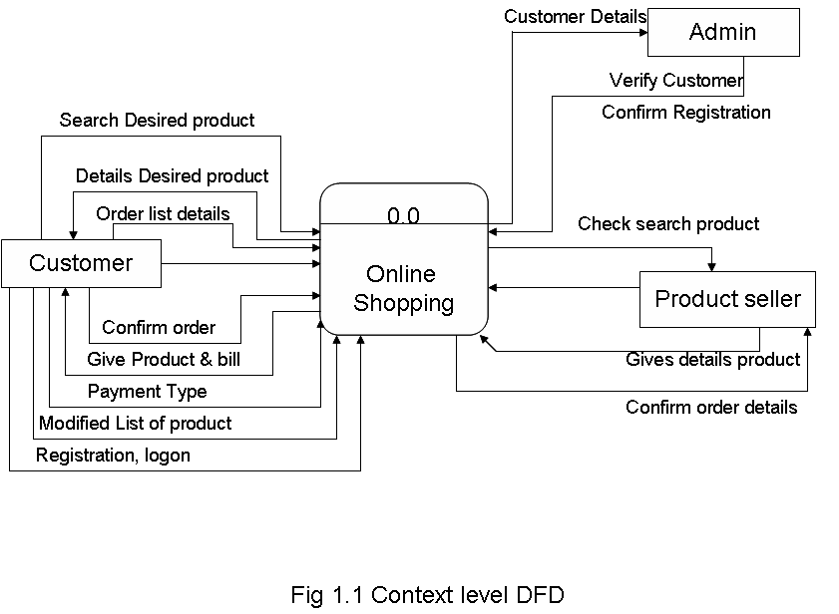

.

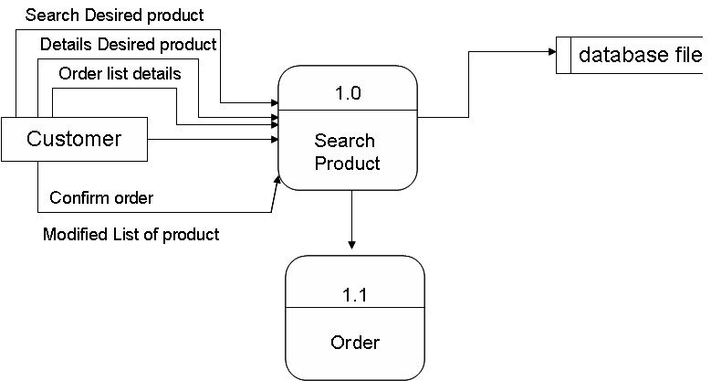

Fig 1.1 First Level DFD

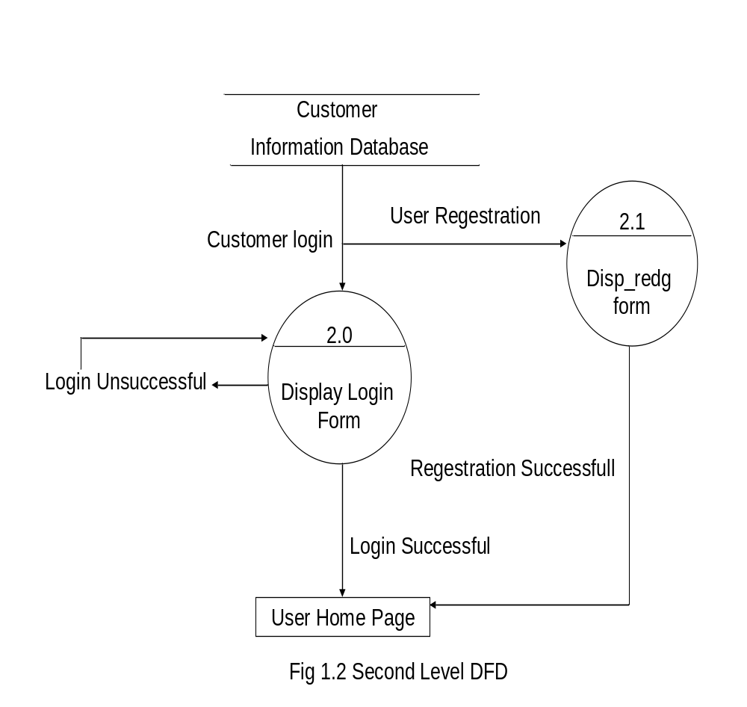

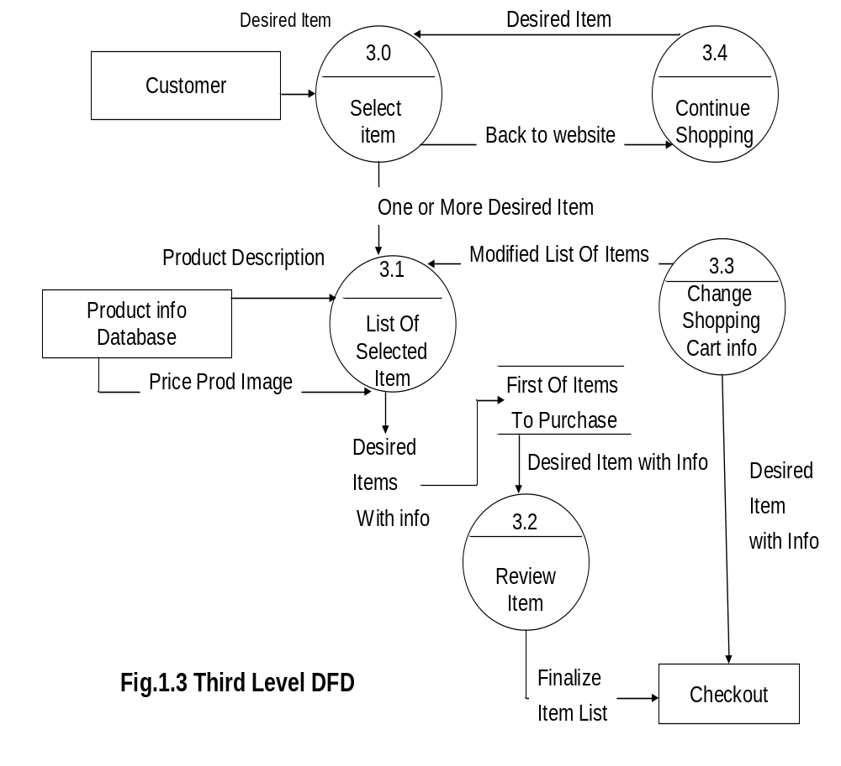

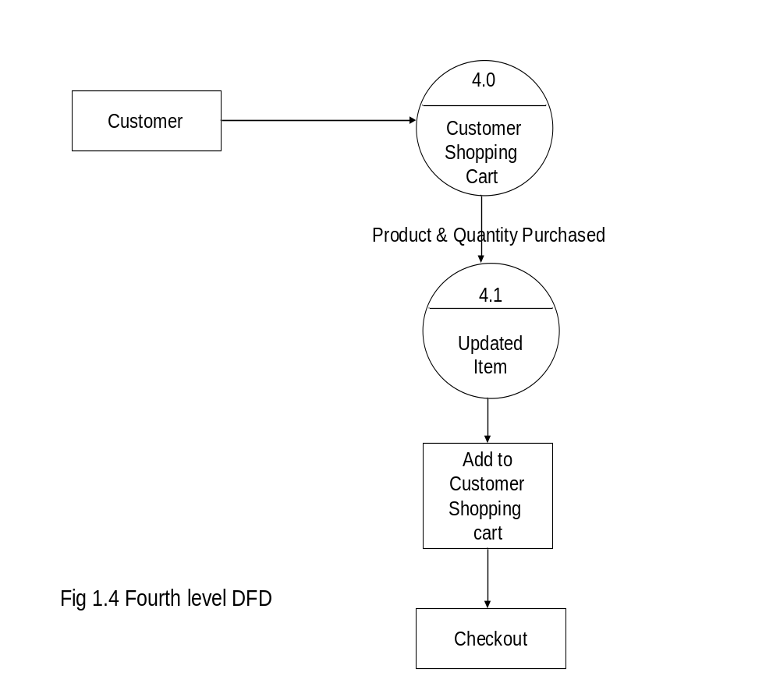

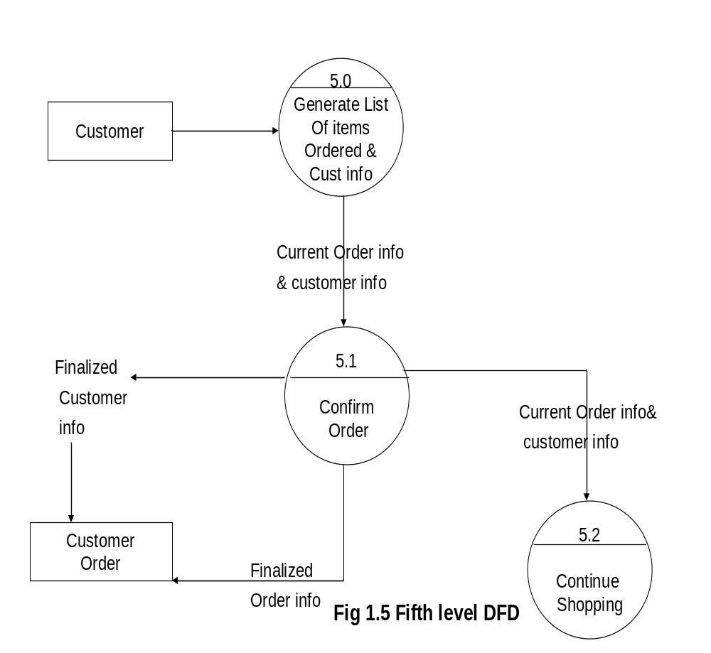

Entity Relationship Diagram (ERD)
The primary purpose of the ERD is to represent data objects and their relationship. ERD enables a software engineer to identify data objects and their relationship using graphical notation. In the context of structured analysis, the ERD defines all data that are entered, stored, transformed, and produced with in an application
The following table summarizes the elements of a data flow diagram and the symbols used to denote them: -

Entity- An entity or data object is a representation of almost any composite information that must be understood by the system or software. Rectangle represents the data object/entity.

Attributes- Attributes define the properties of a data object and take on one of three different characteristics. Ellipse represents the attribute of an entity

E-R Diagram

Password
O_No

U_Name
Phone No
Password
U_ID
O_Date
U_ID
Ad_Name
E-Mail
O_No

U_ID

E-Mail
Password
AD_ID
Ph_No
Place
M
M
ADMIN
USER
ORDER
M
M
1
1
M
Manage
For
PRODUCT
M

Search
Pro_ID
A_ID

Pro_Name
Company

Quantity
Category
Pro_ID
O_No
Pro_ID
Price
M
A_ID
M
O_No
S_ID
Amount
B_datee
B_No
O_No
B_No
Manage
Has
Supplies
By
SUPPLIER
BILL
S_ID
Pro_ID
1
Card_no
Tra_id
date
1
Card_name
Has
S_Name
S_ID
Address
Tra_ID
B_No
ONLINE PAYMENT DETAIL
1
M
M
Phone No
Amount
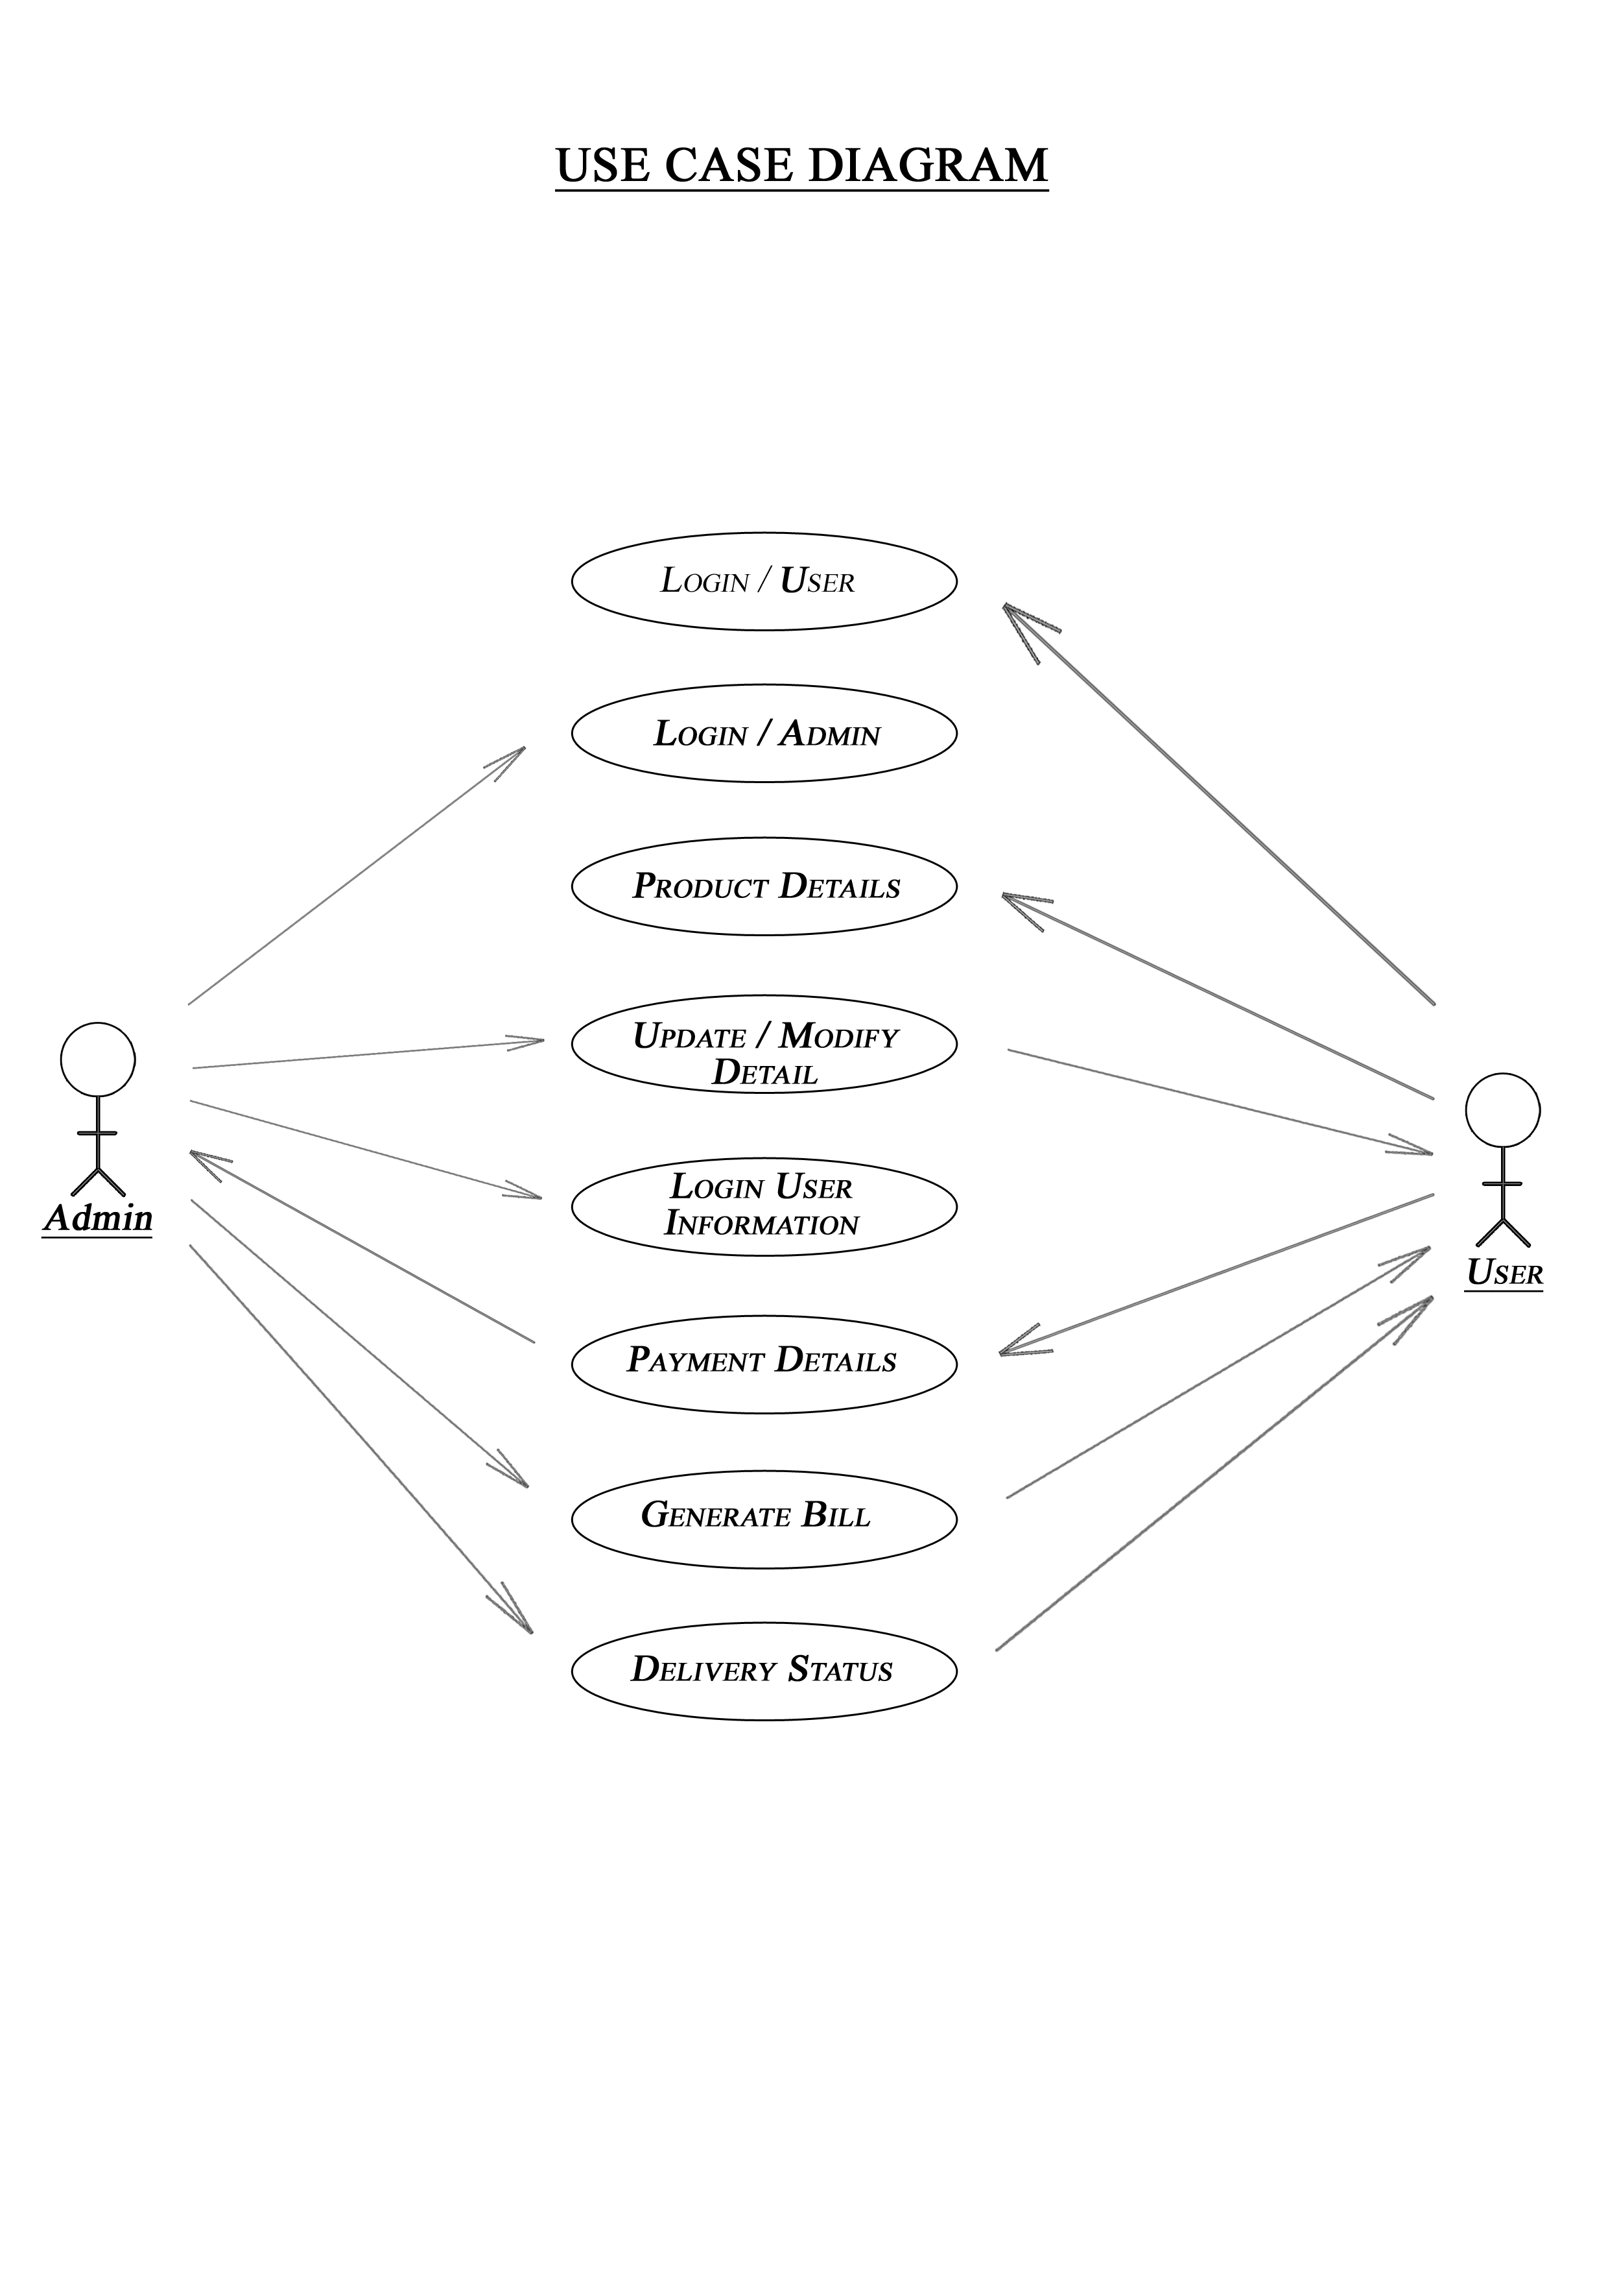

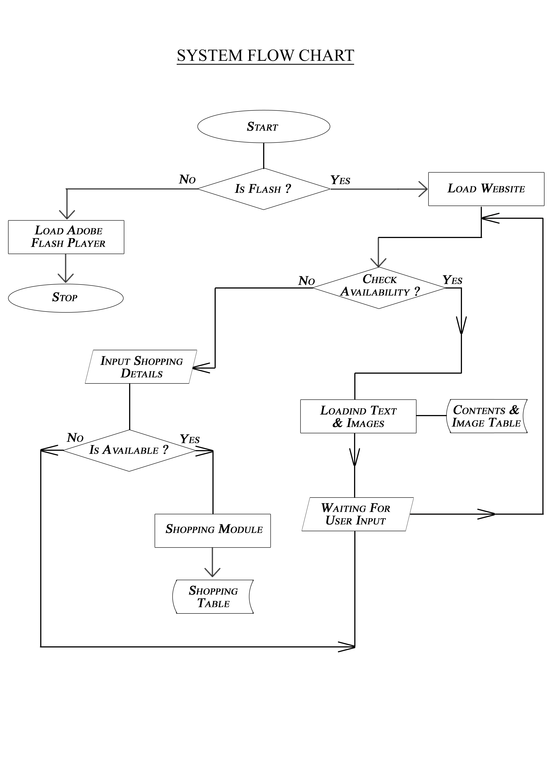

COMPLETE STRUCTURE OF PROJECT

Number of modules and their descriptions:

Module 1: Admin Module
- Adding Category
- Adding Sub Category
- Adding Products
- Modifying Products
- Modifying Sub Category and Category
- view category
- view sub category
- view product
Module 2: User Module
- Registration Form
- Online Payment
- Feedback Form
- Search for product
- Query

Module 3: Search Module
- Search Engine

Module 4: Database Design
- DFD
- Relationship
- Transaction
DATABASE DESIGN

Table 1:- ADMIN

Table Fields
Fields | Constraints | Data Type | Size | Description
Ad_id | Primary Key | Int | 50 | Unique admin Id
Password |  | Varchar | 20 | Holds Encrypted Password
Ad_name |  | Varchar | 25 | Name of admin
E_mail |  | Varchar | 30 | Email id of admin
Ph_no |  | Int | 10 | Admin’s phone number

Table 2:- USER

Table Fields
Fields | Constraints | Data Type | Size | Description
U_id | Primary Key | Int | 50 | Unique User Id
Password |  | Varchar | 20 | Holds Encrypted Password
U_name |  | Varchar | 25 | Name of user
E_mail |  | Varchar | 30 | Email id of user
Ph_no |  | Int | 10 | User’s phone number

Table 3:- ORDER

Table Fields
Fields | Constraints | Data Type | Size | Description
Or_no | Primary Key | Int | 50 | Unique order number
Password |  | Varchar | 20 | Holds Encrypted Password
U_id | Foreign Key | Int | 25 | Link With user table
O_date |  | Date |  | Date of order made

Table 4:- PRODUCT

Table Fields
Fields | Constraints | Data Type | Size | Description
P_id | Primary Key | Int | 50 | Unique Product Id
P_name |  | Varchar | 25 | Name of product
Category |  | Varchar | 20 | Category of product
Company |  | Varchar | 20 | Product relates to
Quantity |  | Int | 10 | Quantity of product
Price |  | Int | 10 | Price of product

Table 5:- SUPPLIER

Table Fields
Fields | Constraints | Data Type | Size | Description
S_id | Primary Key | Int | 50 | Unique Supplier Id
S_name |  | Varchar | 25 | Name of supplier
S_address |  | Varchar | 30 | Address of supplier
Ph_no |  | Int | 10 | Supplier’s phone number

Table 6:- BILL DETAILS

Table Fields
Fields | Constraints | Data Type | Size | Description
B_no | Primary Key | Int | 50 | Unique order number
O_no | Foreign Key | Int | 20 | Link with order table
U_id | Foreign Key | Int | 25 | Link With user table
B_date |  | Date |  | Date of bill generated

Table 7:- PAYMENT DETAILS

Table Fields
Fields | Constraints | Data Type | Size | Description
Tra_id | Primary Key | Varchar | 50 | Unique tansaction id
P_date |  | Date |  | Date of payment made
Amount |  | Int | 5 | Amount to be paid
Card_no | Foreign Key | Int | 20 | Link with card details table
Card_type |  | Varchar | 20 | Type of credit card

Table 8:- CARD DETAILS

Table Fields
Fields | Constraints | Data Type | Size | Description
Card_no | Primary Key | Int | 20 | Unique Card No.
sec_code |  | Varchar | 10 | Last 3 digit code
balance |  | Int | 4 | Balance available with card
cardtype |  | Varchar | 20 | Type of card

Table 9:- FEEDBACK DETAILS

Table Fields
Fields | Constraints | Data Type | Size | Description
Id | Primary key | Int | 10 | Identity of feedback
Title |  | Varchar | 20 | Title of feedback
Description |  | Varchar | 250 | Description of feedback
Date |  | date |  | Date of feedback

Table 10:- TESTIMONIALS

Fields | Constraints | Data Type | Size | Description
Id | Primary key | Int | 10 | Identity of Testimonials
Title |  | Varchar | 20 | Title of Testimonials
Description |  | Varchar | 250 | Description of testimonials
Date |  | date |  | Date of testimonial

TOOLS/PLATFORMS USED

For the undergoing project, following tools are used:
Platform | Windows
Operating System | Windows XP professional with Service Pack 3
Framework | .Net FRAMEWORK 3.5
Front-End Tool | Visual Studio 2008
Scripting Language | C#, HTML
Interface | HTML, Visual Studio
Server | Internet Information Server
Back-End Tool | SQL Server 2008
Technology | ASP.NET

HARDWARE:
Processor | Intel Pentium 2.4 GHZ
Memory | 256 M.B., D.D.R. RAM
Network Adapter | Ethernet Adapter
Modem | 56kpbs Voice Fax Data
Secondary Storage | Samsung/Seagate Hard disk (40 G.B)

SECURITY MECHANISMS

There are mainly two level of security in my software. The first level is known as Supervisor Level. The second level is known as User Level. The supervisor works like the DBA user who is known as Super User. He or She can create new user and his password. He or She can alter any user’s password. He or She can delete user name and his password. He is able to revoke and grant authoriza- tion from or to the user. He is able to every kind of operation on the databases.
The software developed by me contains one of the features i.e. security feature. In my software, only authorized user can access my software. It means that except authorized user nobody cannot access my software. For the security of the software password dialog box has been created in my software in which user has to enter the name as well as password and then OK button is pressed.
In my software, only valid data can be entered by any user. If any user enters invalid data, then error message box will appear on the screen. Since constraints have been applied with some of the fields, no duplicate data can be entered by the user because there are some of the fields, which have been made primary key. Thus no redundancy will be occur and only valid data will be stored in the tables. The fields having primary key always contain unique value.

To protect the data we taken following work: -

- Protect with secret password: For prevent unauthorized access on the computer we given secret passwords to user. This is not so securing because password are generally backup or understand. From the help of refinement of password we restrict the users to use only those areas, which is related to them. Higher authority can do sensitive & critical decision.
- Protect with encryptions: In this a key enables to be coded then send to receiver. Then after receiver decrypt or decode the data

- by using that key. It can also break up by cracking the code or key.
- Computer professionals themselves must ensure computer security: For this user operators should be trained in computer security. Ramification of security lapses should be told very firmly by them & healthy respect for computers should be installed in them.

Some more security measures are as follows:

- Always take a backup.
- Record properly on backup register.
- To ensure about misuse of computer.
- Audit trail.
- Recovery.

LIMITATIONS

As we all aware of this matter that each and every thing has its own limitation, my project has its own limitation.
SCOPE OF FUTURE APPLICATION

The future scope and enhancement of the project is a continuous process. Whenever the client wants some additional features in the website he interacts with the development team. The project is made in such a way so that it can be upgraded in the future and lots more feature can be included whenever required.
I want to make the following further enhancement in the project: -
- I want to make the website AJAX enabled so that the page can update without requiring a full page refresh.
- I want to use the concept of WEB PARTS in the project.
- I would like to make this website using .NET 3.5
- I want to enrich this website with the concept of SharePoint.
- I want to build this website by using Silver Light Technologies that provides a great look to the website.
- Finally I want to make this website fully Secure and User Friendly.

BIBLIOGRAPHY

- Database System Concepts By Henry F Korth
- Software Engineering By Roger Pressman
- System Analysis & Design By Whitten
- Professional ASP.NET 1.1 By Alex Homer, Dave Sussman
- Professional C# By Simon Robinson,Bill Evjen

Websites:

http://www.dotnetspider.com
http://forums.asp.net
http://codeproject.com
http://www.w3schools.com

